CHAPTER 4

Confidence Intervals and Hypothesis Tests

Confidence Intervals

A confidence interval is an expression of the uncertainty when a sample is taken from a population. It is expressed as a percentage and the greater the percentage confidence the larger the interval becomes. If the sample is large (often large is taken to be thirty or more) the confidence interval is given by:

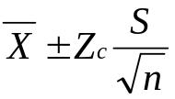 where n is the sample size, 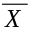 is the sample mean, S the sample standard deviation and Z_{c} comes from the normal probability tables and is a factor for the percentage confidence required. Typical values of Z_{c} are:

Confidence level | 99% | 95% | 90% | 80%
Z_{c} | 2.58 | 1.96 | 1.645 | 1.28

Where do the number in the tables come from?

To see this in action consider the car sample. Statistics on the miles per gallon for the three countries is given in the following table;

Sample Average Standard
Level size deviation
--------------------------------------------------------
U.S.A. 85 25.2624 6.11974
Europe 25 32.5520 8.18062
Japan 44 33.4795 5.27277
--------------------------------------------------------

This can also be reflected in boxplots:

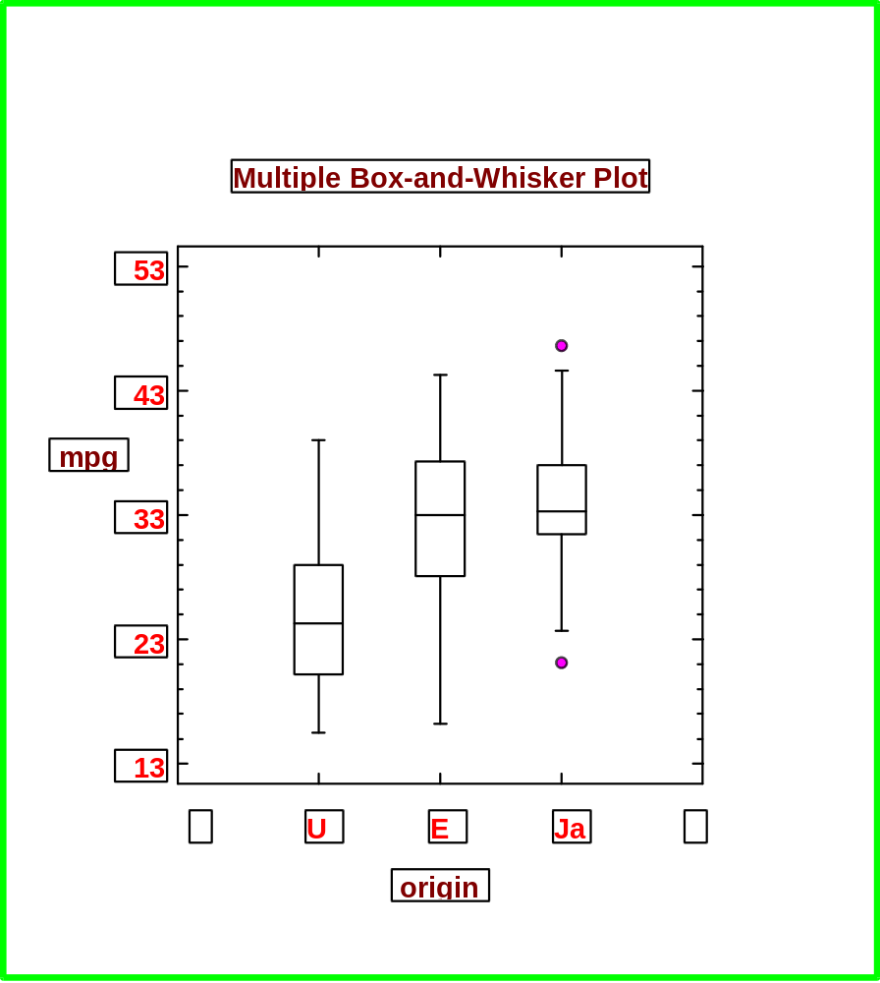

The 95% confidence interval for the mean mpg of American cars is claculated from:

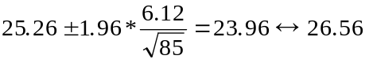

The 95% confidence interval of European cars is :

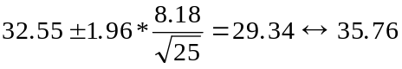

While for Japanese cars the 95% confidence interval is :

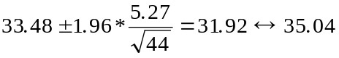

This can be illustraed diagramatically as:

Japan

Europe

U.S.A.

22 24 26 28 30 32 34 36
MPG

How does this compare with the boxplot?

From this we ask if the origins of cars makes a significant difference. This introduces the idea of Hypothesis Tests.

This concept is one of assessing evidence that would lead to one rejecting the NULL Hypothesis (H_{o}) in favour of the ALTERNATIVE Hypothesis (H_{a}).

Ho: The mpg of Japanese cars is not significnatly different from 25 mpg.

v

Ha: Japanese cars’ mpg is significantly greater than 25 mpg.

This is tested by determining if:

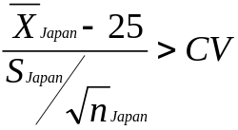

where CV is the critical value

Level of Significance | 0.5% | 1% | 5% | 10%
Critical value for one tailed test | 1.28 | 1.645 | 2.33 | 2.58
Critical value for a two tailed test | 1.645 | 1.96 | 2.58 | 2.81

Testing at the 5% significance level (95% confidence) we get:

This was an example of a one tailed test. A two tailed would be:

Ho: The mpg of Japanese cars is not significnatly different from 25 mpg.

v

Ha: Japanese cars’ mpg is significantly different from 25 mpg.

Here because the direction is not indicated to test at the 5% level our rejection region is no longer for greater than 95% but for Z_{c} greater than 97.5%. Why?

Thus we get:

What about the more interesting question of:

Ho: There is no significant difference between American and Japanese cars

v

Ha: There is Japanese cars are significantly more fuel efficient than American cars.

The problem here is what to use for S in the formula. We have to pool the standard deviations from the two samples and use the formula:

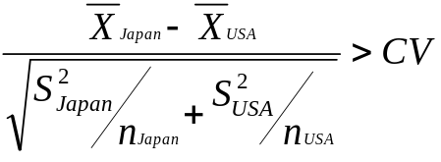

Testing at the 5% level we get:

This there a difference between the mpg of European and Japanese car?

There are two types of mistakes that can occur which sholud be minimised. These are:

 |  | Ho True | Ha True
Decision | Accept Ho | Correct Decision | Type II error
 | Reject Ho | Type I error | Correct Decision

Proportions

Consider the following scenario:

there are two offices O_{a} and O_{b}. O_{a} processess 100 accounts every week for 30 weeks and there are on average errors in 10 of the accounts per week. O_{b} processess 150 accounts every week for 40 week and on average makes errors in 20 of the accounts per week. What is the 95% confidence interval for the number of mistakes made by O_{a}?

For large samplese use :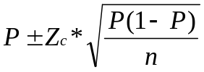

Hence the answer is 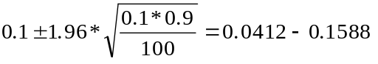

Are the number of errors made by O_{a} significanctly less than 15% ?

The hypothesis statements are:

We use the expression 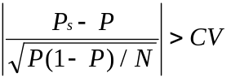

Hence we get: 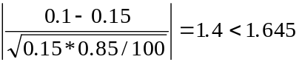

Thus we do not have sufficient evidence to reject H_{o}.

Is there a sigificant difference in the performance of the two offices?

The hypothesis statements are:

To determine this we use:
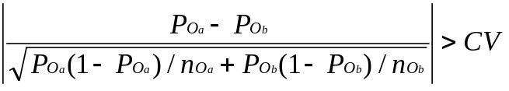

This gives:

What do we do about small samples i.e. less than 30?

Small Samples

Here the Student t - distribution is used see Appendix 6 and for confindence intervals we have the factor t_{c} instead of Z_{c}. The value of in dependent of the smaple size and the first column of table in Appendix 6 is the degree of freedom (df).

For example

Confidence Interval | 99% | 95% | 90% | 80%
t_{c} for df = 9 | 2.82 | 1.83 | 1.38 | 0.883

Consider the times two employees take to carry out similar tasks. Each employees was timed to do the task ten times. These times, in minutes, appear in the following table:

Employee A | 10 | 8 | 8 | 100 | 10 | 11 | 15 | 12 | 13 | 13 | 14
Employee B | 13 | 16 | 15 | 76 | 18 | 14 | 17 | 19 | 14 | 17 | 18

Any observations from this table?

The percentage confidence interval of the mean interval is given by

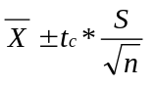

What is the 95% confidence interval for the mean of employee A?

= S = d.f. = t_{c} =

C.I. =

Is the average time taken by employee A significnatly less than 15 minutes at the 5% level?

To answer this we compute the test statistic 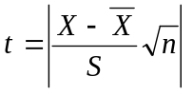 if this is bigger than the value in the tables then the null hypothesis is rejected.

The hypothesis statements and the required calculations are:

Is there a significant difference between employee A’s and employee B’s average times?

To answer this we have to decide if the samples have been matched, which means in this case that the tasks and the environment would be identical. In the matched case the test stastistic would be computed from:

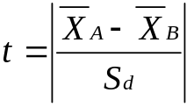
Where S_{d} is the standard deviation of the differences between A and B’s times. This matched pairng is unlikely to have existed and the unpaired test should be used. For this the test statistic is:

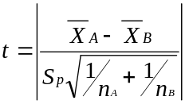

Where S_{p} is the pooled standard deviation and is given by:
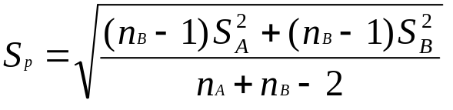

Thus for the case in question we get:

Test for Comparing the Variability of Two Groups

If both the groups are normally distributed then ratios of one variance to the other follow an F distribution. Thus one can test:

H₀: Both variances are equal
V
H_{a}: The variances are not equal

The ratio 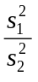 is compared to 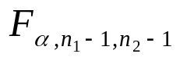

Example.

10 samples were drawn from bottles of perfume produced by two different processes and tested for “potency”.
The mean score and variance for one process was 10.37 and 0.105. While for the other the figures were 9.83 and 0.058.

To compare variances one computes:

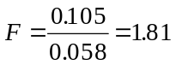 which is less than F_{0.025,9,9} (i.e. 4.03) and so it is concluded that there is insufficient evidence not to assume that the varianv=ces are equivelent.

Fortunately these days all this can easily be done using computers.

The ideas presented in this chapter are expanded upon the next chapter.

